RESUME
1. Applying job |  |  |  |  | 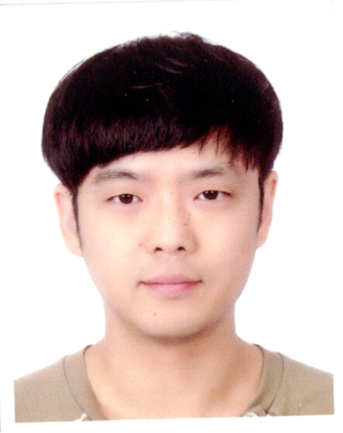
Trust & safety Analyst
2. Personal Data
Full Name | Lee-hyunmin | Phone
Birthday | 1985. 08. 09 | Mobile | +66)080-737-9692
E-mail | g7aria@naver.com | Fax
Address | 301 -115 Niam Uthit Alley, Khwaeng Din Daeng, Din Daeng, Bangkok 10400
3. Education
Period | Name of school |  |  | Location | Degree
2001-2004 | Dongwon high school |  |  | Suwon
2006-2013 | Hannam univercity - korean education |  |  | Daejeon | bachelor
2016-2017 | shenzhen university |  |  | china shenzhen | certificate
4. Experience
Perod | Name | Details
2007-2009 | korea Forest Service | office assitant / administraion assistant, computer work
2012 | Institution | teacher / teaching middle school students korean language
2014 | Reading room | manager / receive new member, manager office supplies
2016-2017 | shenzhen korea school | teacher / teching korean language,
2019~2021 | Bus process delivery(MY) | Categorizing data
2021~2022 | QA(MY) | Quality Assurance for project
2023~ | Trust & safety Analyst(TH) | Checking reported case
5. Skills
Computer | basic powerpoint ,excel, word skils
Languages | intermediate English available(B2) - I can communicate fluently with foreign friends by English
 | basic Chinese - i can talk basic conversation by Chinese
 | Korean navtive
6. Activities
7. Self Introduction
i had lived in china for about one year half. so i can work with foreigners and become familiar with the others. if there is something to solve, i want to solve clearly
I have invested stock from 5 years ago, and think strategic about preventing risk. And have knowledge about economic and stock
I have teaching experience. And sometimes teach Korean language for learner. So I can teach new experience or knowledge for Quality Assurance
I have worked BPO companies and know some countries as well.
9. Honors And Award
Second grade of Regular teacher licence
studying group award in university
10 Reference
I have worked RUNWAY project for almost 3 year, and lead team member’s quality for 1 year half. And handle different some projects together

