Curriculum vitae
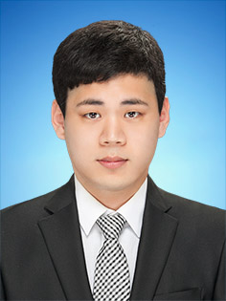
=

Personal information
Name : Kim jihun
Phone : 0812 9817 1852
E-mail : gulet4508@naver.com
Address : Jl.Nusantara Raya Depok 172

Job experiences
Korean – English, English – Korean freelance translator in Indonesia Anindyatrans – from January of 2016 - now
Working holiday in Perth, Australia for 6 months worked at steggles as factory worker in 2015
Elementary English teacher in personal educational institute Korea ESL어학원 – for 1 year in 2013 to 2014
Junior high school students English teacher in personal educational institute Korea 가경입시학원 – for 6months in 2015
Cashier in seven eleven, green 24, supermarket (in Korea) - for 3 years 6months [2011~2014]
Many kinds of jobs experience such as factory process worker, construction site, manager of accommodation (private dormitory as called 고시원) [2013~2015]

Education / Certificate
Management information system Department in Chung-buk national university. (2008 ~ 2014.08)
TOEIC SCORE : 810 (Institution : YBM/한국TOEIC위원회)

Dear whom it may concern this CV
My name is Kim jihun 28years old, I’m hard-working, motivated person who enjoy working in team situations but also work independently. I’m also comfortable with using MS word, Excel, Power point.
It’s also possible to communicate confidently with professional written and verbal communication skills in Korean, English and Indonesia as intermediate low.
I’m happily ready to work and contribute to the company.
Please concern this resume for your vacant position.

